
Recreation ground Management Plan
February 2026
Introduction
The recreation ground is situated near the shoreline of Swanage Bay, offering an open and accessible green space for public enjoyment. Its boundaries are clearly defined: Victoria Avenue forms the northern limit, Shore Road borders the east, and Horsecliffe Lane marks the western perimeter. As its name implies, the area is designated for community recreation and provides a welcoming environment for both residents and visitors with numerous benches provided for residents and visitors to enjoy the spectacular views across the bay
Access to the site is straightforward. Visitors can make use of parking facilities at the nearby Mermond Place car park, while residents benefit from parking bays along Horsecliffe Lane. The grounds also accommodate disabled access from both parking areas, and a zig-zag pathway adjacent to the Santa Fe Fun Park provides convenient access down to the beach. Public toilets are available at Mermond Place car park and along Shore Road with accessible public conveniences available at both locations
The landscape features a gentle slope across the upper section, with steeper banks along the seaward boundary. The site comprises a mixture of maintained grassed areas, meadowland, hedgerows, young trees, ornamental flowerbeds, tarmacked pathways, seating areas, and several notable features, including:
War memorial
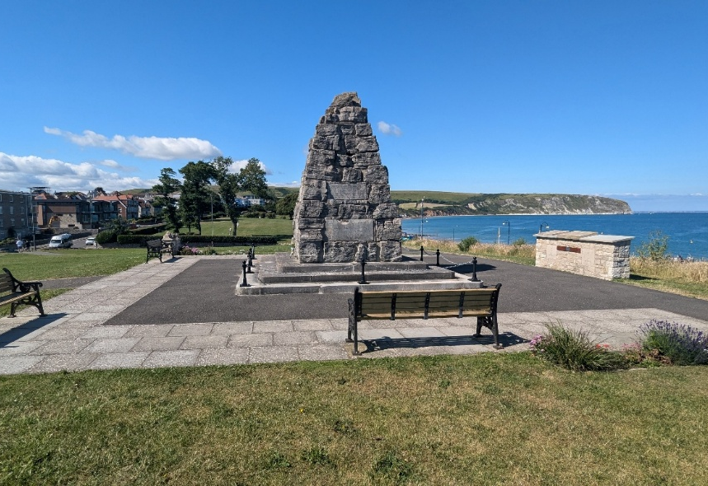
Originally unveiled on 1st August 1920, it was created to honour the local men and women who lost their lives in the First and Second World Wars. The memorial was carefully relocated and rebuilt nearby in 2014 to ensure its preservation as part of a larger Recreation Ground Stabilisation project.
Made from Purbeck stone in a tapering cairn design, the memorial sits on three stepped bases. Stone tablets list the names of 99 local residents who died in the First World War and 65 who died in the Second World War, all serving their country. Additional details relating to the memorial and the names of those remembered can be found here.
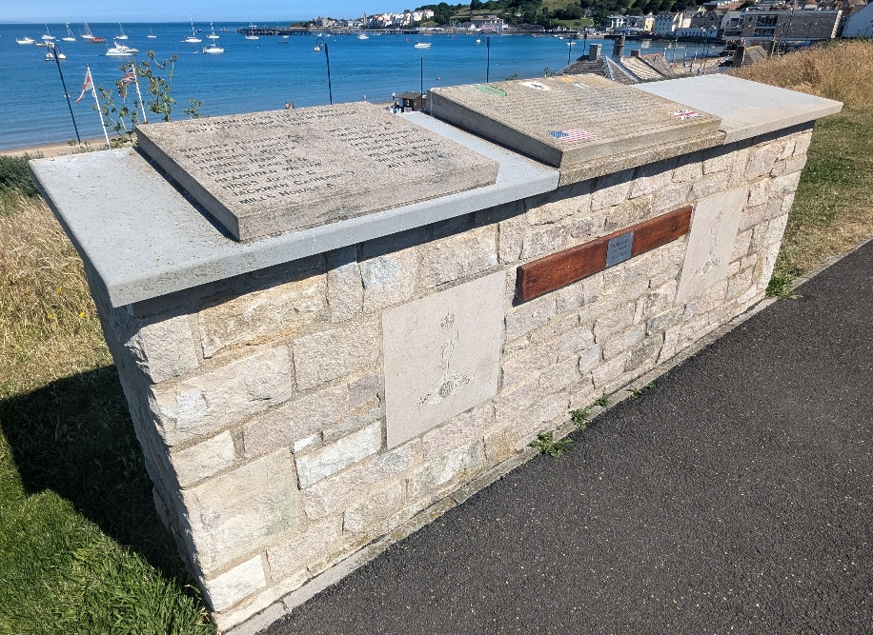
The memorial holds both architectural and emotional significance for the town. As a Grade II listed structure, it is protected for its historic value and remains a central point for remembrance events and reflection within the community.
Adjacent to this sits the Memorial Wall on which a variety of stone tablets commemorating civilian residents that lost their lives in Swanage during the war as well as local schoolchildren who were tragically lost due to an unexploded mine discovered on
the beach.
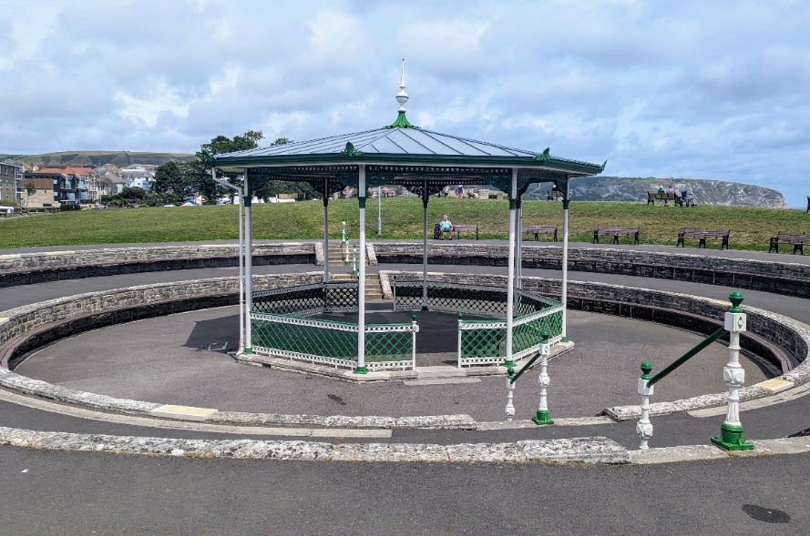
Band stand
Constructed in 1923, the bandstand is an example of a very rare cast-iron structure built by Walter MacFarlane and Co, of Glasgow, for £1280 and is one of only 4 examples of the Macfarlane 224 design remaining in the UK.
Set within a striking, sunken amphitheatre with Purbeck Stone walls (constructed by World War I veterans), it is situated adjacent to the play park and worth visiting.
Severe storm damage occurred in 2011, which uncovered hazardous materials leading to the removal of the roof. The Swanage community pulled together and in 2017 a group of residents formed the ‘Friends of Swanage Bandstand’ to raise the funds needed for the restoration project. With the support of the Town Council, local organisations and charitable trusts, £145,000 was raised and the bandstand was restored back to its former glory, with an official re-opening ceremony in 2019.
The bandstand has hosted many events over its history and to this day, is utilised by bands from all over the country for many recitals and performances across each year.

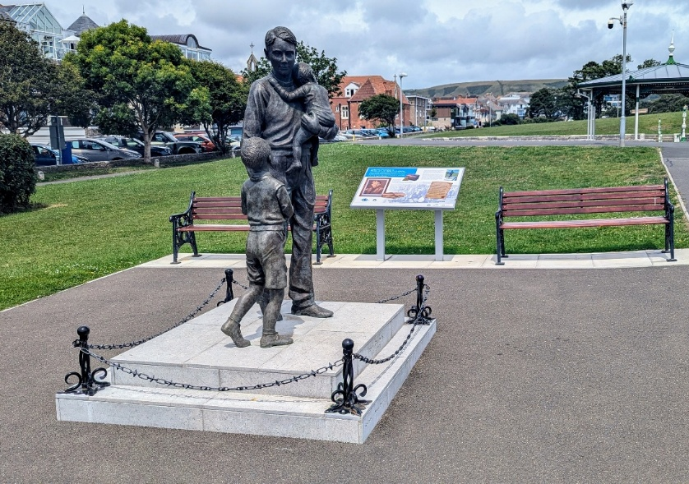
Trevor Chadwick Memorial
The Trevor Chadwick Memorial Statue honours a local hero who helped rescue 669 children from Nazi-occupied Czechoslovakia in 1939 as part of the Kindertransport. Often called the "Purbeck Schindler", Chadwick was a schoolteacher and lifeboat volunteer who worked alongside Sir Nicholas Winton to carry out this life-saving mission.
Unveiled in August 2022, the life-sized bronze statue by sculptor Moria Purver shows Chadwick gently holding one child while guiding another - capturing his compassion and bravery. It stands on a handcrafted Purbeck Stone plinth beside the bandstand, and the renamed Trevor Chadwick Playground.

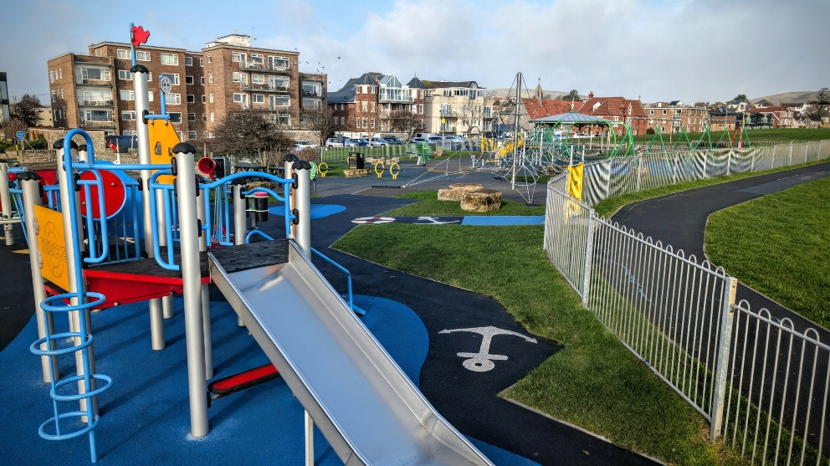
Trevor Chadwick Playground
A lively destination throughout the year, this popular spot for local families and visitors underwent a refurbishment in 2021 and now features a durable all-year surface, a variety of children’s play equipment, including a trampoline, swings, a roundabout, and a seesaw. Several items of play equipment were selected for their accessible and inclusive design.
Certain features such as the lifeboat styled multi-play climbing structure were chosen in acknowledgement of the role of Trevor Chadwick as a Swanage RNLI Lifeboat Volunteer.

Management plan
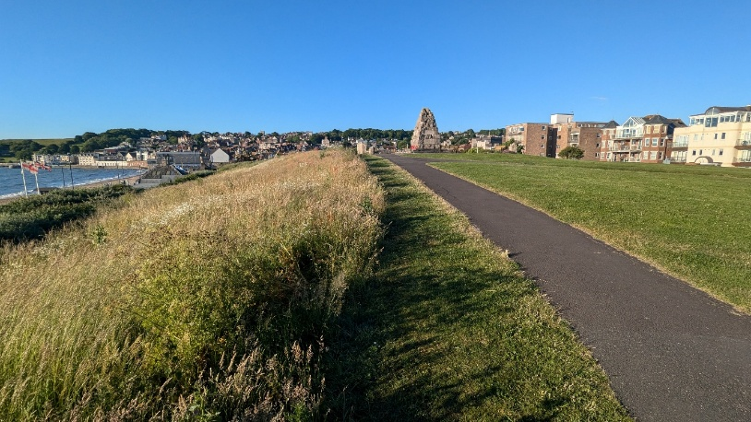
Grounds Maintenance
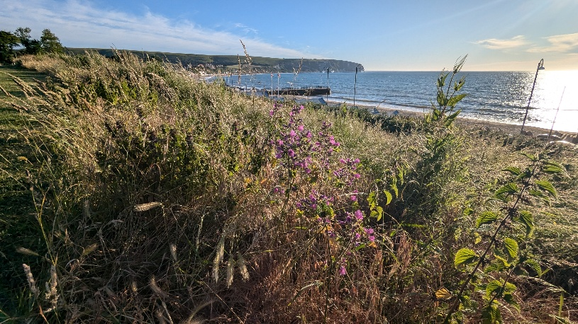
The upper section of the site, characterised by its gentle slopes, is mown or strimmed throughout the year, with frequency determined by seasonal growth and ground conditions. Some small areas on the higher ground are intentionally left uncut to support the conservation of rare plant species, such as orchids.
The bank located behind the beach huts is maintained as meadowland. This area is cut annually in the autumn, and a line of sea buckthorn hedging runs along the rear of the huts. The council has also enhanced this habitat by planting native wildflower plugs and distributing wildflower seed across the bank.
Managing the bank in this way provides several key benefits:
- Enhancing local biodiversity
- Establishing a wildlife corridor
- Reducing the risk of injury to maintenance operatives
- Lowering long-term maintenance costs
- Creating a natural barrier that discourages antisocial behaviour and protects the beach huts
Weed control
Weeding of the paths, monuments, band stand, and car parks, is done by hand or with the use of hoes.
The paths across the site are edged once a year, usually before Remembrance Day.
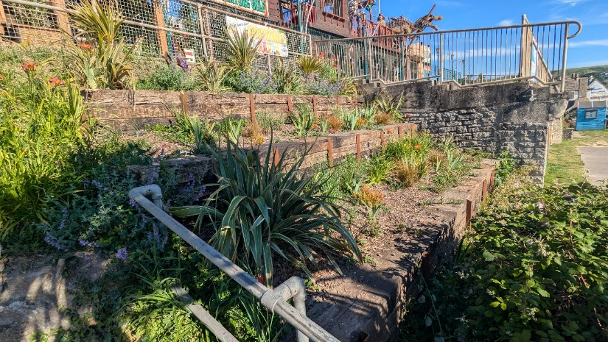
Flower beds
The flower beds are situated below Santa Fe and consist mainly of perennial plants chosen for their appearance and attractiveness to pollinators. Works to stabilise the slope and create a more suitable planting space were completed by council operatives in Jan 2024 by reusing old railway sleepers. Some of the perennial plants used for planting in the beds are: Canna lily, European flax, Phormium, Agapanthus, Day lily, Heather, Bearded iris, Nepeta, Hottentot fig, and Trailing roses.
The flower beds are weeded and mulched with woodchips as needed along with seaweed from the beach. There are also two small flower beds by the war memorial. These two beds have similar planting and maintenance regime as the beds above, with the only difference being that they require more frequent watering during dry spells.

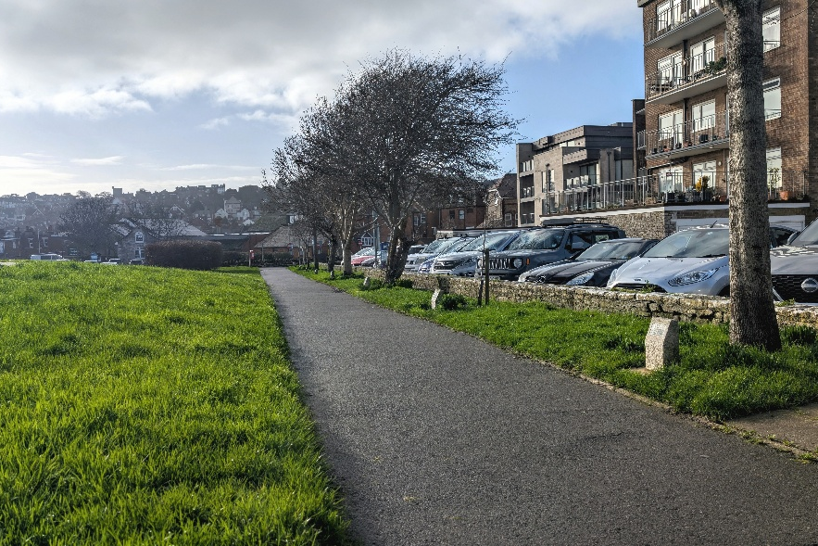
Trees
Trees are present on the Mayor’s Walk and consist of young specimens of: Hawthorn, Acer, Birch, Ash and Whitethorn. All the trees across Council greenspaces are managed and maintained as laid out within the Swanage Town Council Tree Strategy which was adopted in 2022.

